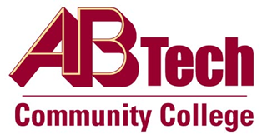

# Asheville-Buncombe Technical Community College (A-B Tech) Policy Manual

## Policy 810.01: Graduation/Program Completion

It is the policy of the Board of Trustees to award Associate’s Degrees, Diplomas and Certificates. To be awarded a degree, diploma or certificate a student must:

1. Declare and be accepted into the program.
2. Complete all requirements of the program.

Program requirements are defined in the College Catalog. The catalog of record for a student’s program is the one in effect when the student begins the program. A catalog is in effect for five academic years. An advisor may change the catalog of record, but not to a catalog year prior to the student’s entry into the program.

Each course in the program of study must be completed according to the policy and procedure for Awarding of Curriculum Credit (Policy 820).

A minimum of 25% of credit applied to a program must be earned at A-B Tech.

The Dean responsible for a course requirement in an academic program may waive or substitute the requirement for a specific student in that program provided the NCCCS requirements for the program of study are met.

All requirements must be completed on or prior to the last day of the term of program completion.

## Scope

Applies to curriculum students

## Definitions

Academic Year: Begins Fall semester and extends through the subsequent Spring and Summer terms. The academic year is identified as the calendar year of the Fall term (e.g. 2011 academic year consists of Fall 2011, Spring 2012 and Summer 2012).

## References

Reviewed by Executive Leadership Team, December 5 and 19, 2012; January 9 and February 21, 2013.

## Policy Owner

Vice President for Student Services, Ext. 7900

See Graduation/Program Completion Procedure

Approved by the Board of Trustees on May 6, 2013.